

**Submitted by** :Rushil Bansal (2110992235)

Riya Sen (2110992232)

Shivam Goel (2110992240)

**Group** : 21

**Project Name** : DREAM DESTINE

**Subject :** BEE

**Submitted to** : Lavish Arora Sir

**DREAM DESTINE (A PERFECT TOUR AND TRAVELS SOLUTIONS)**

PURPOSE OF DOCUMENT

This document serves as an informative guide outlining the features, functionalities, and core objectives of the Dream Destine web application. Its primary purpose is to offer stakeholders, users, and potential partners a comprehensive understanding of the Dream Destine platform, emphasizing its innovative approach to transforming travel experiences in Ethiopia.

INTRODUCTION

*DREAM DESTINE* is a cutting-edge web application that aims to revolutionize travel experiences in Ethiopia. Utilizing the MERN stack (MongoDB, Express.js, React.js, Node.js) and Bootstrap, this platform offers a seamless and intuitive approach to discovering the rich tapestry of Ethiopia's diverse attractions, ranging from vibrant city escapades to immersive historical adventures.

Welcome to MY APP

Welcome to the future of travel exploration in Ethiopia. The DREAM DESTINE app invites you to embark on a journey like never before. Whether you're a solo traveler, a group of adventurers, or a family seeking memorable experiences, Tour ET is here to guide you through the beauty and wonders of Ethiopia.

So, buckle up and get ready to unravel the mysteries, savor the flavors, and create lasting memories with DREAM DESTINE - Your Passport to Ethiopian Adventures.

**TECHNOLOGIES USED**

Frontend

Core Technologies:

React: A JavaScript library for building user interfaces.

Bootstrap: For responsive design and UI components.

Maps and Navigation:

Google Maps API: For interactive mapping and geographical features.

Backend

Main Technologies (MERN Stack):

MongoDB: NoSQL database for storing application data.

Express.js: Web application framework for Node.js.

Node.js: JavaScript runtime for executing server-side JavaScript.

Security and Authentication

JWT (JSON Web Tokens) for secure authentication.

bcrypt.js for password hashing and security measures.

**PREREQUISITES**

Getting Started

npm

npm install npm@latest -g

Integrations:

Other third-party services as required by the application.

**KEY FEATURES**

Diverse Travel Packages: Explore a variety of packages including city tours, group travels, adventure experiences, and historical journeys.

Interactive Google Maps Integration: Navigate through different locales with integrated Google Maps, enhancing the exploration of cities and historical sites.

User Reviews: Engage with community feedback through user reviews, helping travelers make informed decisions.

Responsive and Intuitive Design: Crafted with Bootstrap for a user-friendly experience across all devices.

Login/signup Authentication.

Add to cart option along with price calculator.

Interactive contact us and about us page.

Website reviewing option.

**SNAPSHOTS OF UI**

**Some UI Preview**

**Signin/signup page**

[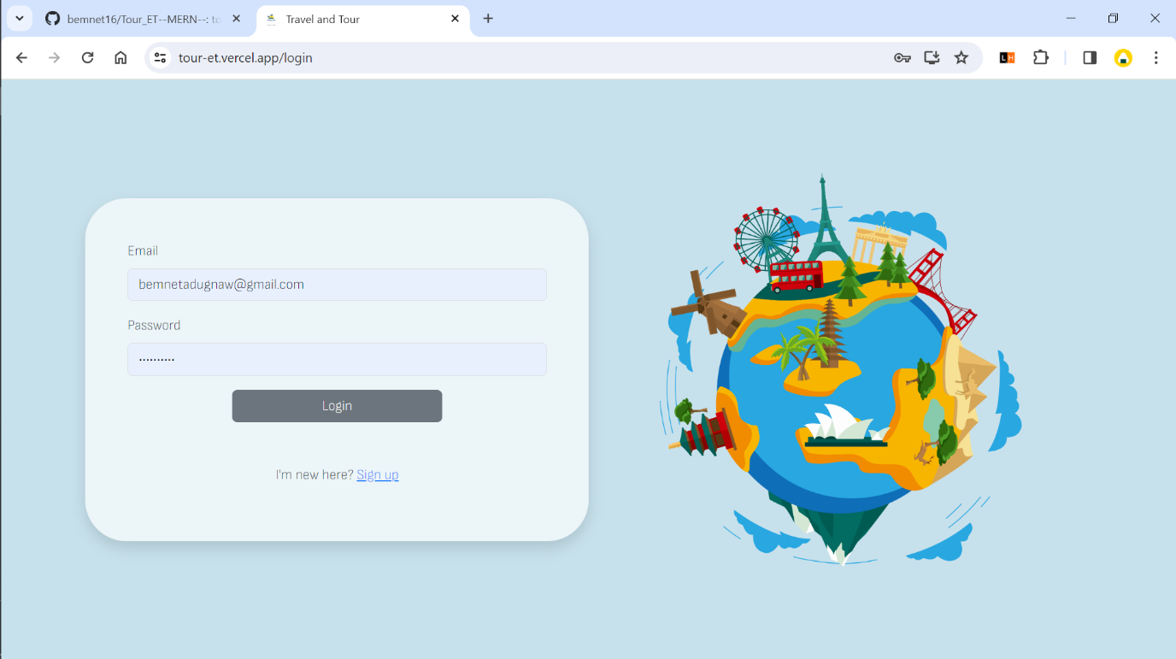](https://github.com/bemnet16/Tour_ET--MERN--/blob/UI-Preview/screenshots/Screenshot%20(611).png)

**Home page**

**Users can see recent package and most popular package lists and also search by location or name**

[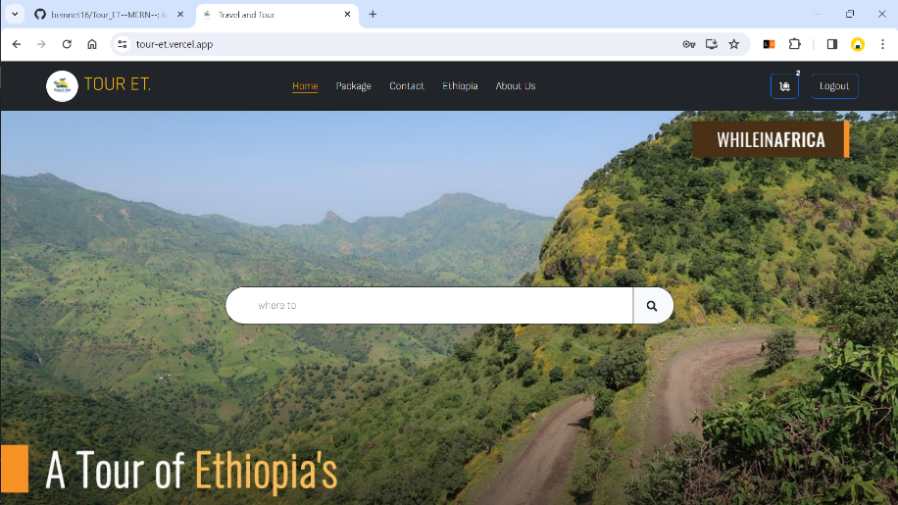](https://github.com/bemnet16/Tour_ET--MERN--/blob/UI-Preview/screenshots/Screenshot%20(595).png) [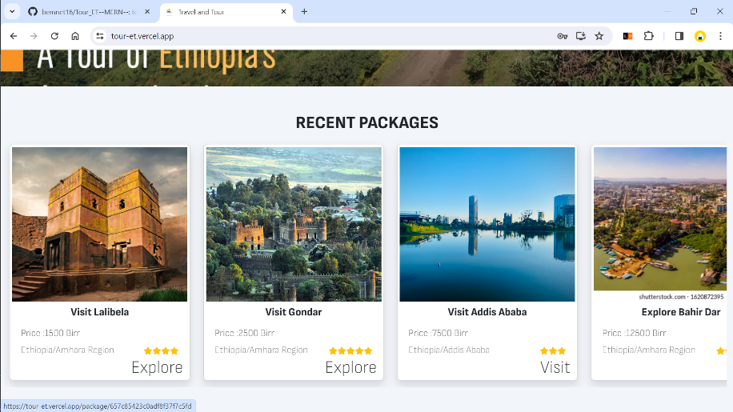](https://github.com/bemnet16/Tour_ET--MERN--/blob/UI-Preview/screenshots/Screenshot%20(596).png) [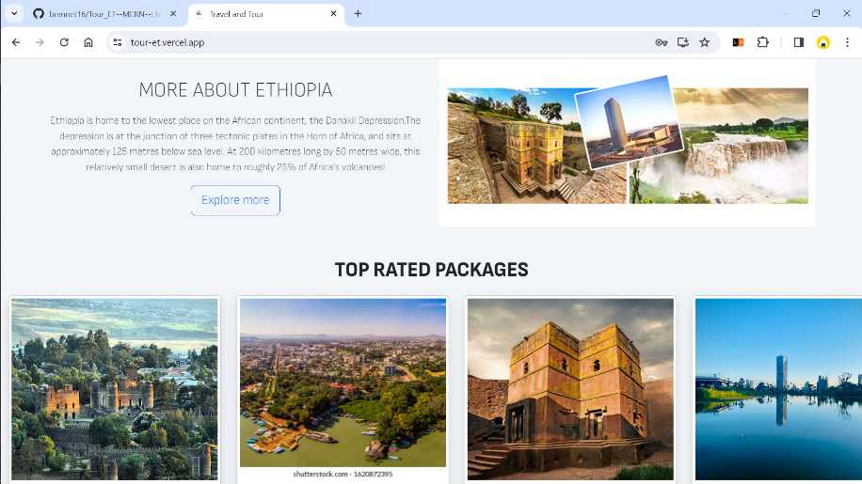](https://github.com/bemnet16/Tour_ET--MERN--/blob/UI-Preview/screenshots/Screenshot%20(597).png)

**Package page**

**Users can see packages and also can filter using different parametes**

[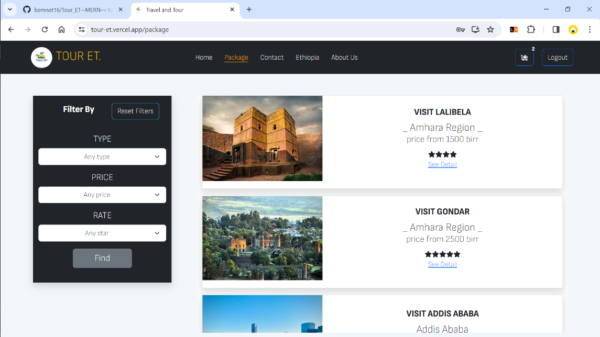](https://github.com/bemnet16/Tour_ET--MERN--/blob/UI-Preview/screenshots/Screenshot%20(598).png)

**Package detail page**

**Users can see package's description, reviews, location, can add to cart, book the package,**

[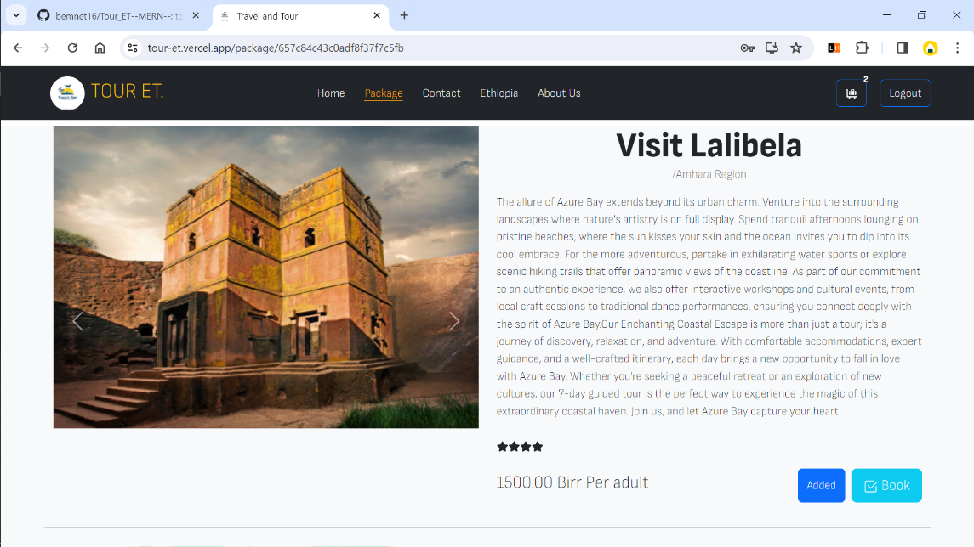](https://github.com/bemnet16/Tour_ET--MERN--/blob/UI-Preview/screenshots/Screenshot%20(599).png) [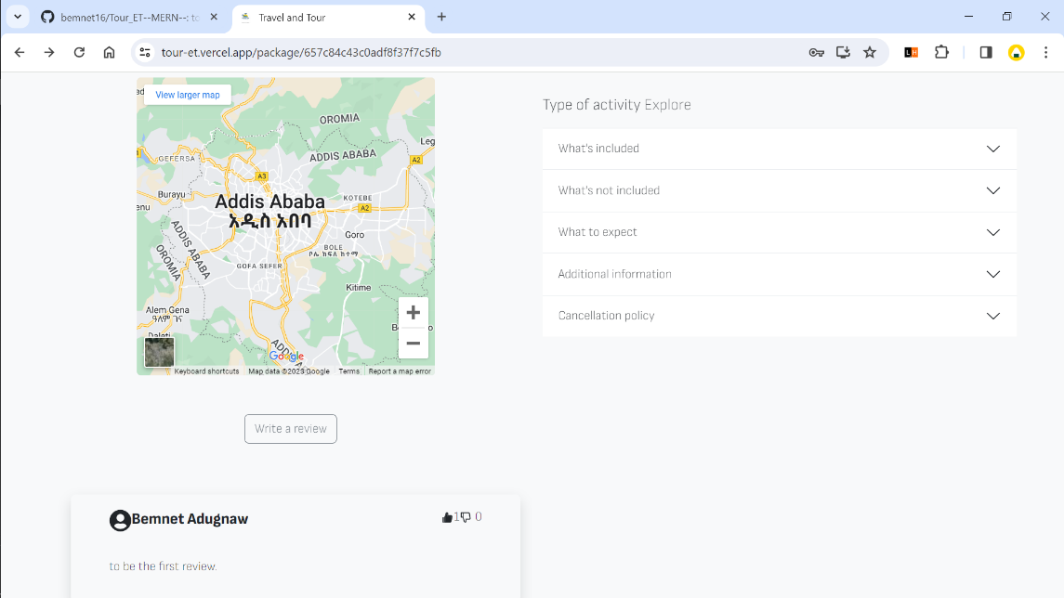](https://github.com/bemnet16/Tour_ET--MERN--/blob/UI-Preview/screenshots/Screenshot%20(602).png)

**Review page**

**Authenticated user can give review/comment, rate the package, like/dislike other's review**

[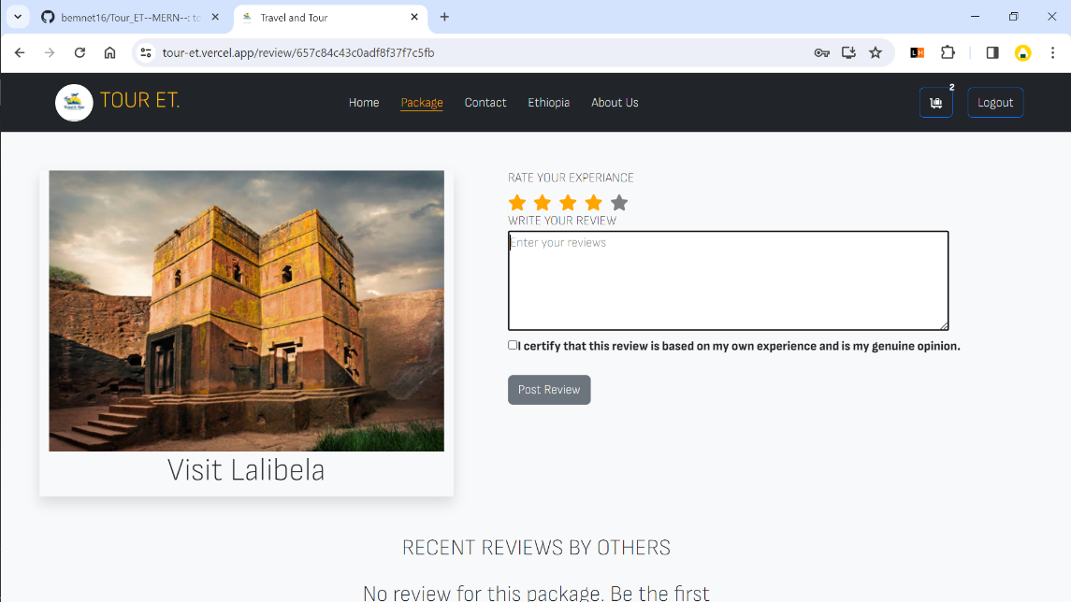](https://github.com/bemnet16/Tour_ET--MERN--/blob/UI-Preview/screenshots/Screenshot%20(601).png)

**Book page**

**Customers check out payment, choose hotel, and room**

[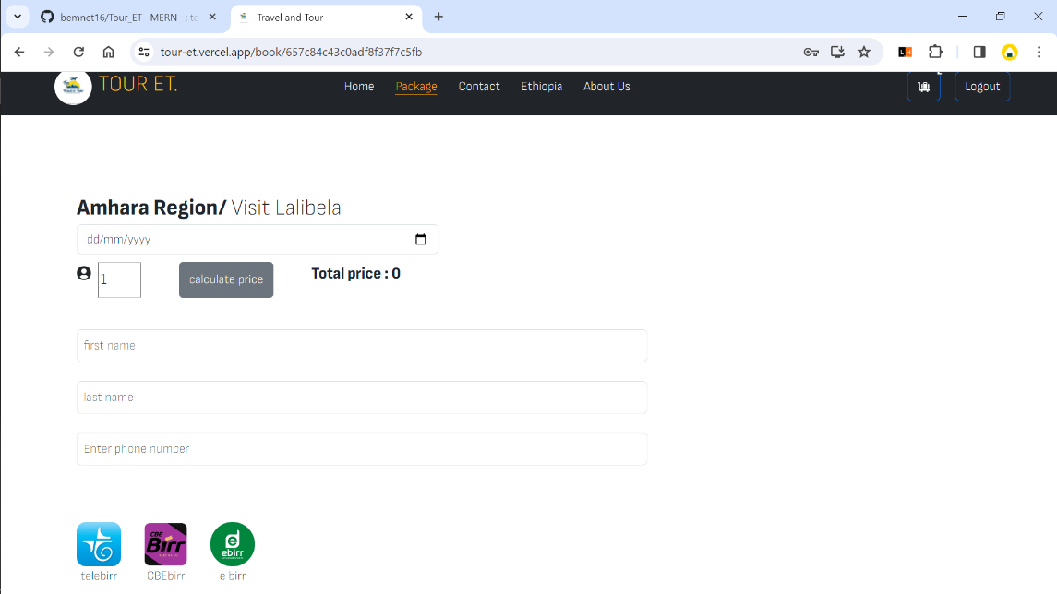](https://github.com/bemnet16/Tour_ET--MERN--/blob/UI-Preview/screenshots/Screenshot%20(603).png) [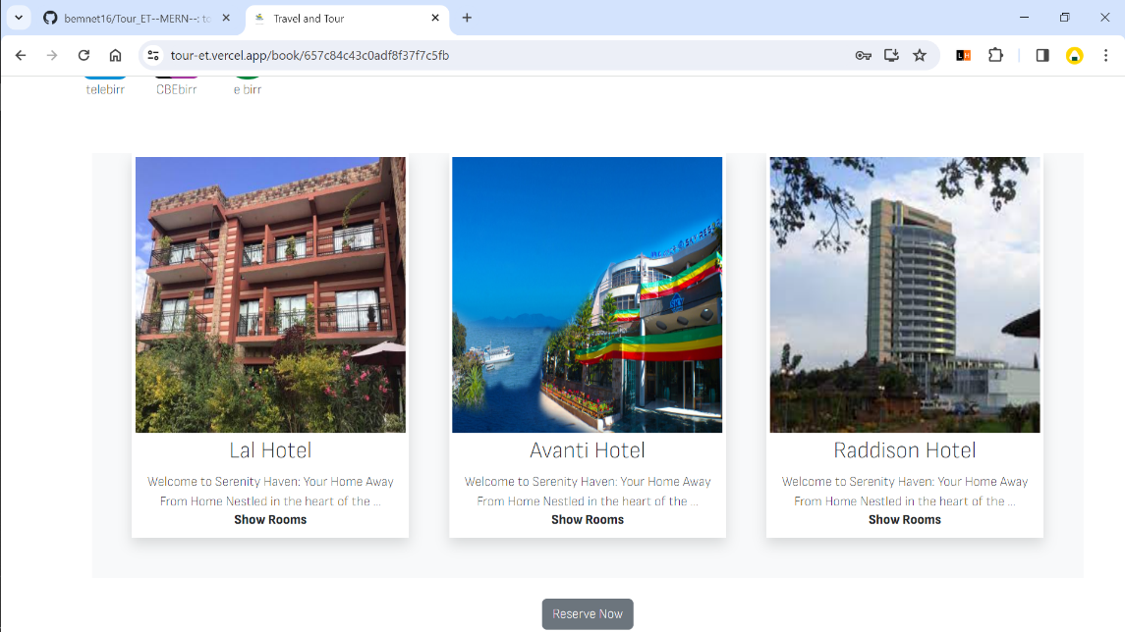](https://github.com/bemnet16/Tour_ET--MERN--/blob/UI-Preview/screenshots/Screenshot%20(604).png) [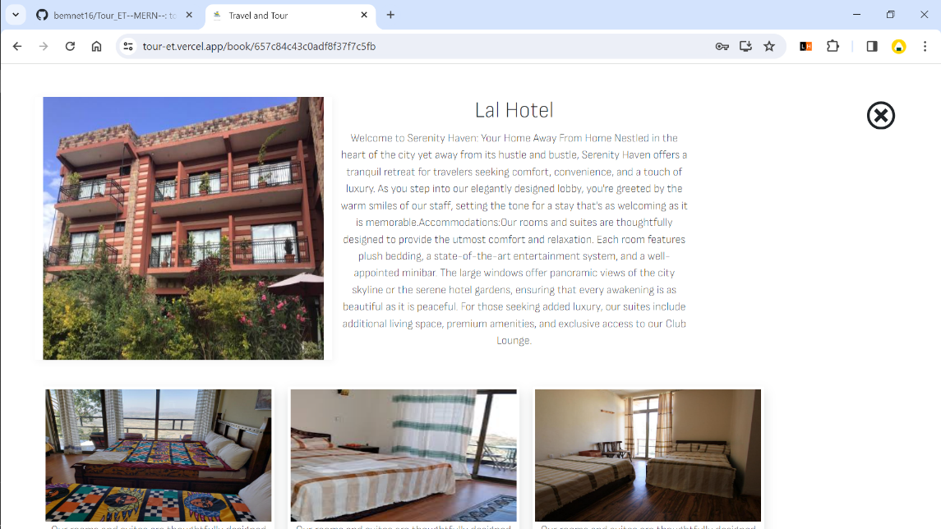](https://github.com/bemnet16/Tour_ET--MERN--/blob/UI-Preview/screenshots/Screenshot%20(605).png) [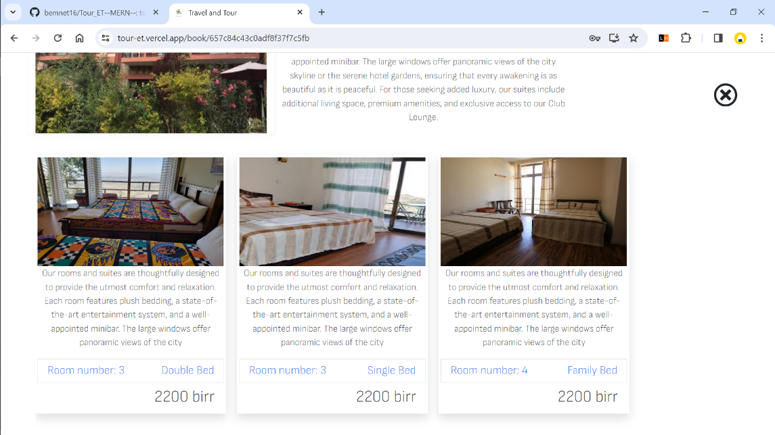](https://github.com/bemnet16/Tour_ET--MERN--/blob/UI-Preview/screenshots/Screenshot%20(606).png)

**Witshlist page**

**Customers can see packages stored in wishlist, remove from here, book here**

[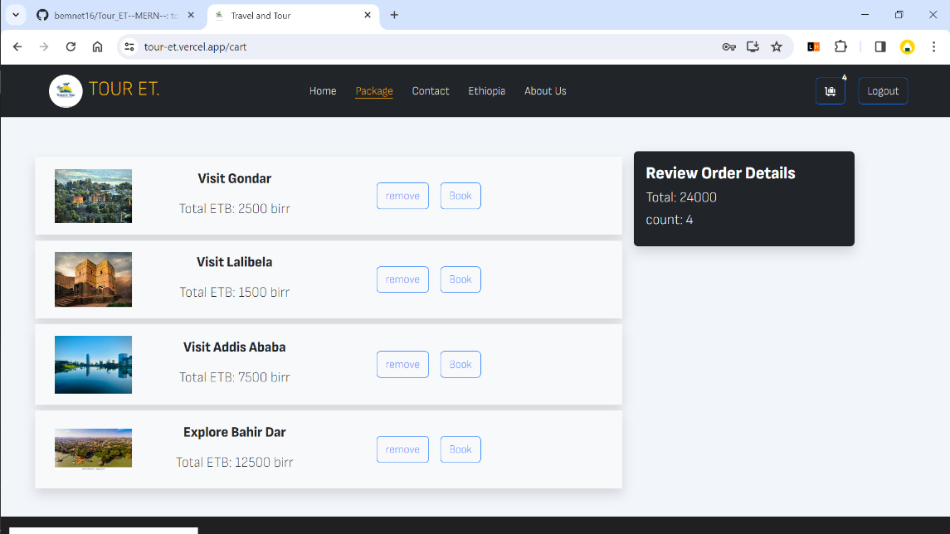](https://github.com/bemnet16/Tour_ET--MERN--/blob/UI-Preview/screenshots/Screenshot%20(607).png)

**Contact page**

**Customers can reach us**

[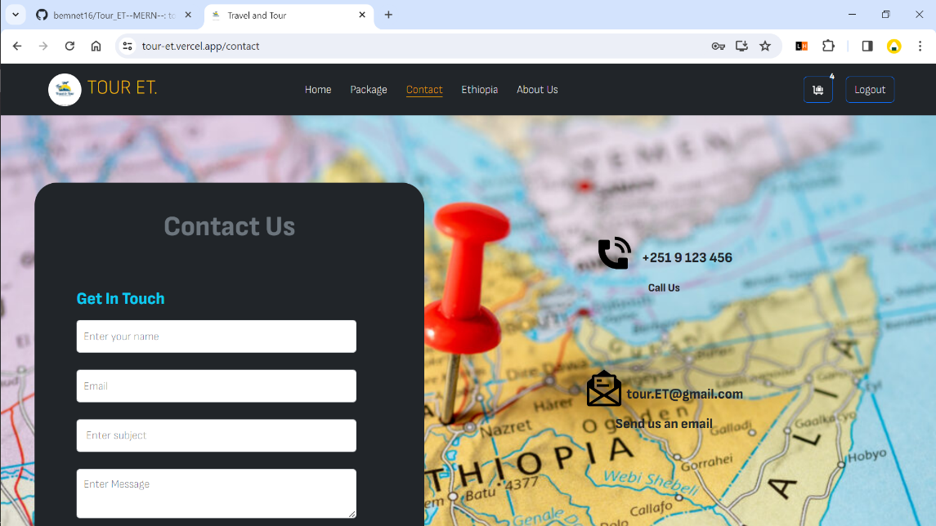](https://github.com/bemnet16/Tour_ET--MERN--/blob/UI-Preview/screenshots/Screenshot%20(608).png)

**About page**

**users can know about us**

[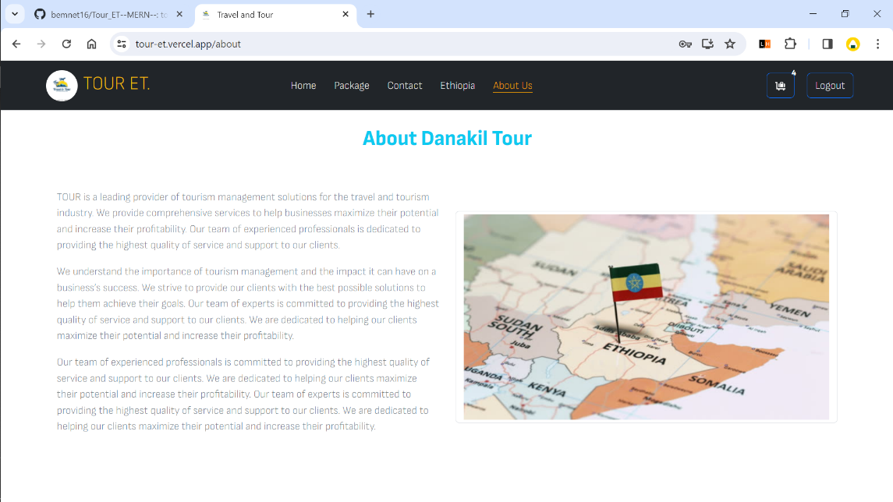](https://github.com/bemnet16/Tour_ET--MERN--/blob/UI-Preview/screenshots/Screenshot%20(609).png) [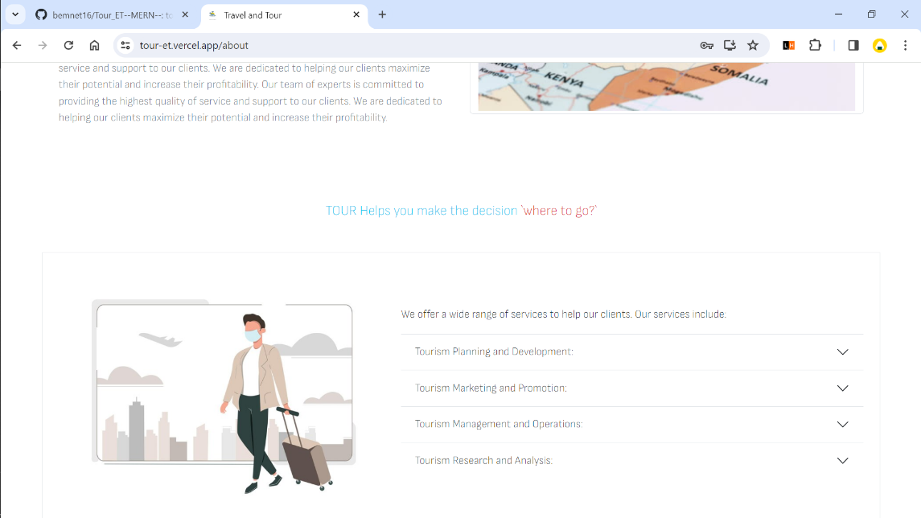](https://github.com/bemnet16/Tour_ET--MERN--/blob/UI-Preview/screenshots/Screenshot%20(610).png)

JWT AUTHENTICATION

Token Purpose:

JWTs are commonly used for authentication and information exchange between parties.

In login/signup scenarios, JWTs help securely transmit information about the user's identity and permissions.

Compact and URL-Safe:

JWTs are compact, making them suitable for transmission as URL parameters or within HTTP headers.

They are URL-safe and can be easily included in web requests.

Token Components:

A JWT consists of three parts: Header, Payload, and Signature.

The Header specifies the algorithm used to generate the signature.

The Payload contains claims, which are statements about an entity (typically, the user).

The Signature is generated by combining the encoded Header and Payload with a secret key.

Stateless Authentication:

JWTs enable stateless authentication, as the server doesn't need to store session information.

Each request from the client includes the necessary authentication information in the JWT.

Token Issuance (Login):

During login, the server generates a JWT after successfully authenticating the user.

The JWT typically includes user details (e.g., user ID, username) and may have an expiration time.

Token Verification (Login):

When a user logs in and receives a JWT, subsequent requests to protected routes include this token.

The server verifies the token's signature to ensure it hasn't been tampered with and is issued by a trusted source.

Token Expiry and Refresh (Login):

JWTs often have an expiration time, reducing the risk associated with long-lived tokens.

Some systems implement token refresh mechanisms, allowing users to obtain a new JWT without re-entering credentials.

Role-Based Access Control (RBAC):

JWTs can include claims specifying the user's roles or permissions.

Role-based access control ensures that users only access resources they are authorized to use.

Signup and Initial Token:

After successful signup, the user might receive an initial JWT for immediate authentication.

This JWT can be used until the user logs out or the token expires.

Secure Transmission:

It's crucial to transmit JWTs securely, especially over untrusted networks.

Using HTTPS is essential to encrypt the communication channel between the client and server.

Token Blacklisting:

In some systems, a token blacklisting mechanism might be implemented to handle compromised tokens or log out users.

Revocation Challenges:

JWTs are stateless, which means revoking a token (e.g., due to a compromised account) might be challenging without additional mechanisms.

CONCLUSION

In conclusion, Dream Destine stands as more than just a travel platform; it is an embodiment of an enriched exploration experience in Ethiopia. Seamlessly combining cutting-edge technology through the MERN stack and Bootstrap with a user-friendly interface, Dream Destine beckons all adventure enthusiasts to embark on a journey like never before. From city escapades to historical marvels, this platform promises an immersive and comprehensive discovery of Ethiopia’s diverse tapestry. As you navigate through Dream Destine, may you find not just a tool for travel planning but a companion for creating indelible memories. Embrace the future of travel exploration in Ethiopia with Dream Destine — Your Gateway to Extraordinary Adventures. Safe travels and may your dreams find their destined reality through the wonders of Ethiopia.